Worksheet 7.2

Cycles in nature
Answers

The nitrogen cycle
1. The following diagram summarises the nitrogen cycle in nature.
(a) Explain why nitrogen is such an important chemical in nature.
Nitrogen is essential for the construction of proteins and DNA and so the nitrogen has to be available in food webs in a suitable nutrient form.
(b) Identify two decomposers at point X.
Bacteria, fungus
(c) Identify the ways that ammonia can enter the soil.
Ammonia enters the soil in several ways: due to the action of decomposers; nitrates in the soil being converted by denitrifying bacteria; waste nitrogen from animals

(d) Explain why ammonia does not build up in the soil.
Nitrifying bacteria convert the ammonia into nitrites and then nitrates which are then absorbed by plant roots.

The recyclers
2. Matter and energy are recycled in nature. The nitrogen cycle, carbon cycle and water cycle are very important systems. These cycles involve living things as well as non-living things.
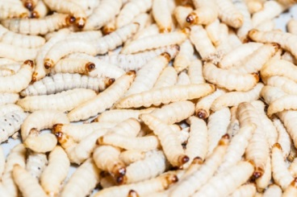  - Maggots |   (b) Bacteria |   Photos:  Maggots: Dario Lo Presti / 123RF  Bacteria: dtkutoo / 123RF  Fungi: jarous / 123RF  (c) Fungi
Explain the role of each of the decomposers shown in terms of recycling matter.
(a) Maggots are the larvae of flies. The flies lay their eggs on dead bodies and so the larvae feed on these bodies and break them down.
(b) Bacteria will grow on both living and non-living matter. They break down the matter and recycle nutrients.
(c) Fungi feed on dead material. They exude chemicals to decompose dead remains and the nutrients then become available to the ecosystem.

